ASSET CLASS RETURNS
Asset Class | Ticker | 1M | 3M | 12M | 3Y | 5Y | 10Y
US Large Cap Equities | SPY | 2.38% | 8.21% | 21.40% | 22.54% | 17.51% | 14.53%
US Large Cap Equities (C$) | XUS.TO | 3.09% | 9.64% | 21.75% | 23.40% | 18.44% | 15.01%
US Small Cap Equities | IWM | 1.76% | 12.55% | 14.30% | 11.77% | 11.33% | 9.30%
Canadian Equities | XIC.TO | 0.96% | 11.67% | 28.68% | 19.43% | 17.58% | 11.68%
International Developed Equities (EAFE) | VEA | 1.77% | 8.99% | 25.70% | 20.22% | 12.49% | 7.99%
International Developed Equities (EAFE-C$H) | VI.TO | 4.19% | 8.70% | 21.81% | 18.44% | 15.29% | 8.98%
Emerging Markets Broad | VWO | 1.46% | 10.95% | 21.99% | 19.37% | 7.78% | 7.62%
Emerging Markets Broad (C$) | VEE.TO | 2.23% | 12.17% | 22.06% | 19.77% | 8.26% | 7.79%
Commodities | GSG | 1.04% | 1.80% | 8.97% | 2.03% | 17.46% | 3.12%
Gold | GLD | 3.56% | 21.51% | 45.21% | 34.32% | 15.88% | 12.91%
US REITs | VNQ | (2.45%) | 1.00% | (1.50%) | 6.81% | 7.14% | 5.25%
US Inflation Protected Bonds | TIP | 0.32% | 2.37% | 5.88% | 4.36% | 1.42% | 2.83%
US Total Bond Market | AGG | 0.62% | 2.96% | 6.20% | 5.47% | (0.26%) | 1.85%
US IG Credit | LQD | 0.15% | 3.09% | 6.69% | 7.65% | (0.10%) | 3.03%
US High Yield | JNK | (0.06%) | 2.19% | 8.06% | 9.70% | 4.63% | 4.74%
Canadian Total Bond Market | XBB.TO | 0.98% | 3.27% | 4.96% | 5.28% | 0.09% | 2.02%
Canadian IG Credit | XCB.TO | 1.05% | 2.89% | 6.75% | 7.43% | 1.96% | 3.08%
US Long Term Treasury Bonds | TLT | 1.38% | 5.04% | 1.98% | 1.74% | (7.84%) | (0.42%)
Canadian Dollar | FXC | (0.80%) | (1.19%) | (0.15%) | 0.49% | (0.25%) | (0.26%)
Hedge Funds | QAI | 0.69% | 4.07% | 8.55% | 9.29% | 4.03% | 3.05%

Source and Notes:
Return calculations performed by Anchor Pacific using FLARETM by Anchor Pacific Financial Risk Labs Ltd. based on monthly values sourced from Yahoo Finance, QuoteMedia, and Fundata. All returns greater than one month assume reinvestment of dividends.
Risk measures the annualized standard deviation of monthly returns for 5 years based on the above data.
Returns are US$ for SPY, IWM, VEA, VWO, GSG, TIP, AGG, JNK, LQD, TLT, FXC, QAI, and VNQ. Returns are C$ for XUS.TO, XIC.TO, VI.TO, VEE.TO, XBB.TO, and XCB.TO. Please see disclaimer for further details.
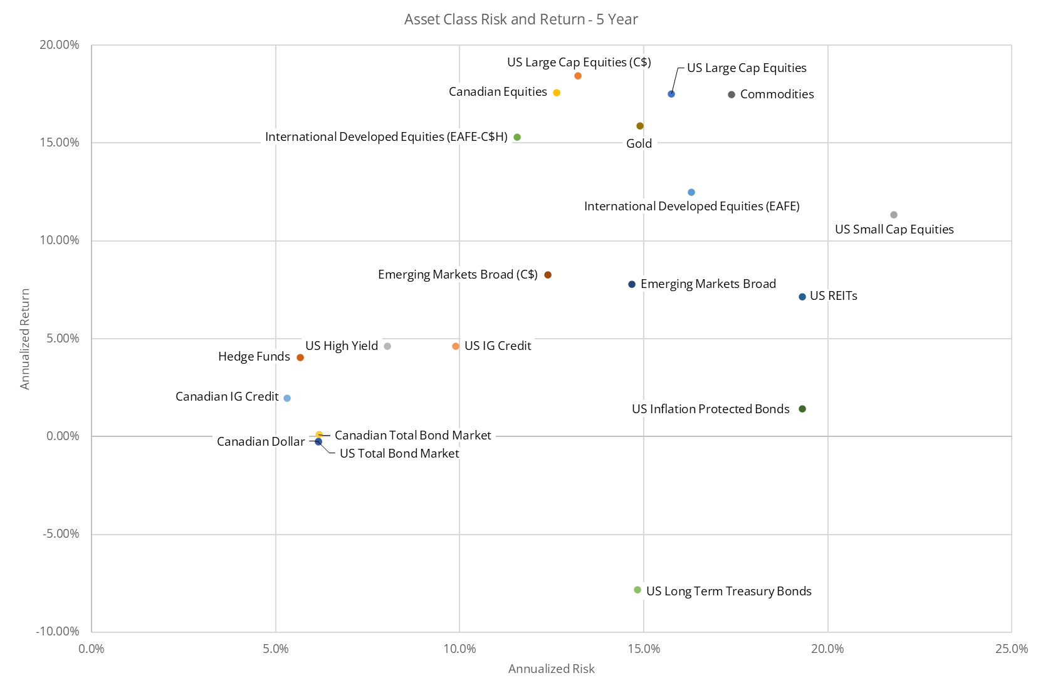

KEY INDEX LEVELS AND RATES
Index/Security | Oct 2025 | 1M  Ago | 3Ms  Ago | 6Ms  Ago | 12Ms  Ago | 1M Delta | 3M  Delta | 6M  Delta | 12M Delta
S&P 500 | 6,840.20 | 6,688.46 | 6,339.39 | 5,569.06 | 5,705.45 | 2.27% | 7.90% | 22.83% | 19.89%
S&P/TSX Composite | 30,260.74 | 30,022.81 | 27,259.78 | 24,841.68 | 24,156.87 | 0.79% | 11.01% | 21.81% | 25.27%
5Y US Gov Bond Yield | 3.71 | 3.74 | 3.96 | 3.72 | 4.15 | (3 bps) | (25 bps) | (1 bps) | (44 bps)
5Y Canadian Gov Bond Yield | 2.70 | 2.75 | 3.03 | 2.68 | 3.03 | (5 bps) | (33 bps) | 2 bps | (33 bps)
10Y US Gov Bond Yield | 4.11 | 4.16 | 4.37 | 4.17 | 4.28 | (5 bps) | (26 bps) | (6 bps) | (17 bps)
10Y Canadian Gov Bond Yield | 3.12 | 3.19 | 3.47 | 3.09 | 3.22 | (6 bps) | (35 bps) | 3 bps | (10 bps)
30Y US Gov Bond Yield | 4.67 | 4.73 | 4.89 | 4.66 | 4.47 | (6 bps) | (22 bps) | 1 bps | 20 bps
30Y Canadian Gov Bond Yield | 3.58 | 3.63 | 3.76 | 3.44 | 3.29 | (5 bps) | (18 bps) | 14 bps | 29 bps
US Bond Yield Curve (3m -10y) | 0.22 | 0.14 | -0.04 | -0.14 | -0.36 | 8 bps | 26 bps | 36 bps | 58 bps
US High Yield (Option Adjusted Spread) | 2.85 | 2.80 | 2.86 | 3.94 | 2.88 | 5 bps | (1 bps) | (109 bps) | (3 bps)
USD/CAD | $1.40 | $1.39 | $1.39 | $1.38 | $1.39 | 0.65% | 1.13% | 1.54% | 0.56%
USD/Euro | € 0.87 | € 0.85 | € 0.88 | € 0.88 | € 0.92 | 1.71% | (1.04%) | (1.79%) | (5.66%)
USD/Yen | ¥154.01 | ¥147.92 | ¥150.76 | ¥143.07 | ¥152.03 | 4.12% | 2.16% | 7.65% | 1.30%
Gold | $3,996.50 | $3,873.20 | $3,348.60 | $3,319.10 | $2,749.30 | 3.18% | 19.35% | 20.41% | 45.36%
Oil (WTI) | $60.98 | $62.37 | $69.26 | $58.21 | $68.81 | (2.23%) | (11.95%) | 4.76% | (11.38%)
CBOE Volatility Index (VIX) | 17.44 | 16.28 | 16.72 | 24.70 | 23.16 | 7.13% | 4.31% | (29.39%) | (24.70%)

Source and Notes:
FLARETM by Anchor Pacific Financial Risk Labs Ltd., Yahoo Finance, QuoteMedia, Fundata Canada Inc., investing.com, US Department of the Treasury (https://www.treasury.gov/resource-center/data-chart-center/interest-rates/), and Federal Reserve Bank of St. Louis Economic Research (FRED) (https://fred.stlouisfed.org/)
Please see disclaimer for further details.

Source and Notes:
Yield curves are calculated for Canada based on data provided by investing.com for 1 month, 3 months, 1 year, 3 years, 5 years, 10 years, 20 years, and 30 years.
Yield curves are calculated for the US based on data provided by the US Department of the Treasury’s website (https://www.treasury.gov/resource-center/data-chart-center/interest-rates/) for 1 month, 3 months, 1 year, 3 years, 5 years, 10 years, 20 years, and 30 years.

DISCLAIMER
Anchor Pacific Investments (“Anchor Pacific”) is a trade name of Aligned Capital Partners Inc. (“ACPI”). ACPI is regulated by the Canadian Investment Regulatory Organization (www.ciro.ca) and a Member of the Canadian Investor Protection Fund (www.cipf.ca).

This publication is for informational purposes only and shall not be construed to constitute any form of investment advice, offer or solicitation to buy or sell any investment fund, security or other product or service. The views expressed are those of the author and may not necessarily be those of ACPI. Opinions expressed are as of the date of this publication and are subject to change without notice. Information has been compiled from sources believed to be reliable. This publication has been prepared for general circulation and without regard to the individual financial circumstances and objectives of persons who receive it. You should not act or rely on the information without seeking the advice of an appropriate professional.

Past performance is not indicative of future performance, future returns are not guaranteed, and a loss of principal may occur. Content may not be reproduced or copied by any means without the prior consent of Anchor Pacific and ACPI.

